**Query Document**

1. **Larry’s Response: In order to remove previous lessons, I realize that I am going to have to have the ability to access all lessons from all of the teachers from my “School Admin” dashboard. Therefore “Lessons” needs to be added to the “School Admin” dashboard list. I can also now see the need to sometimes add “Lessons” and “Templates” and to be able to edit templates from my School Admin dashboard. (see mock up below)**

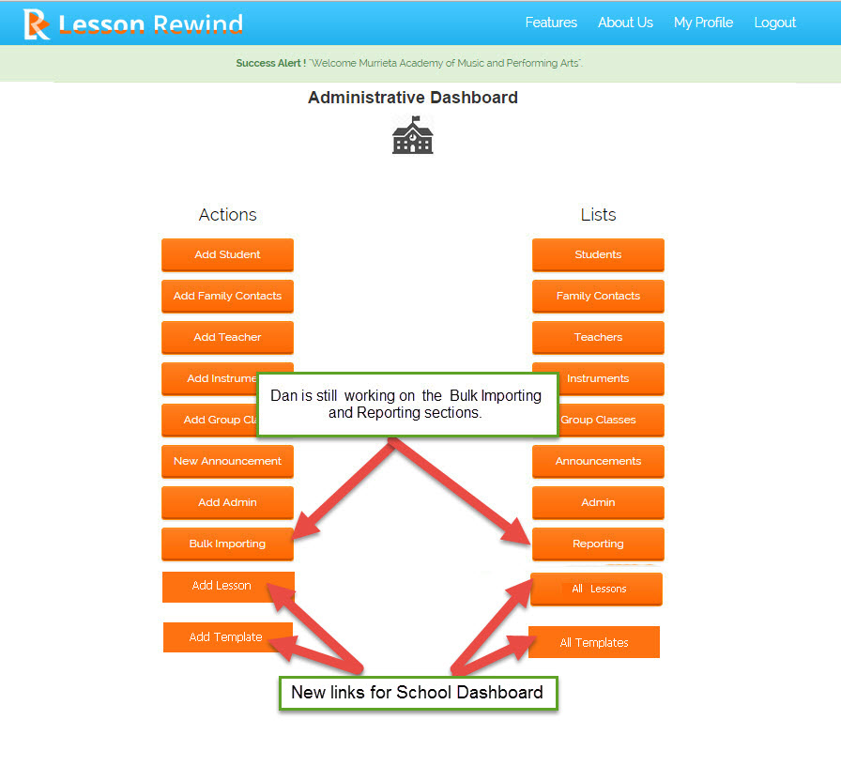

**“Add Lesson by Admin” page for School Administrator to choose Lesson or Class. (mock up below)**

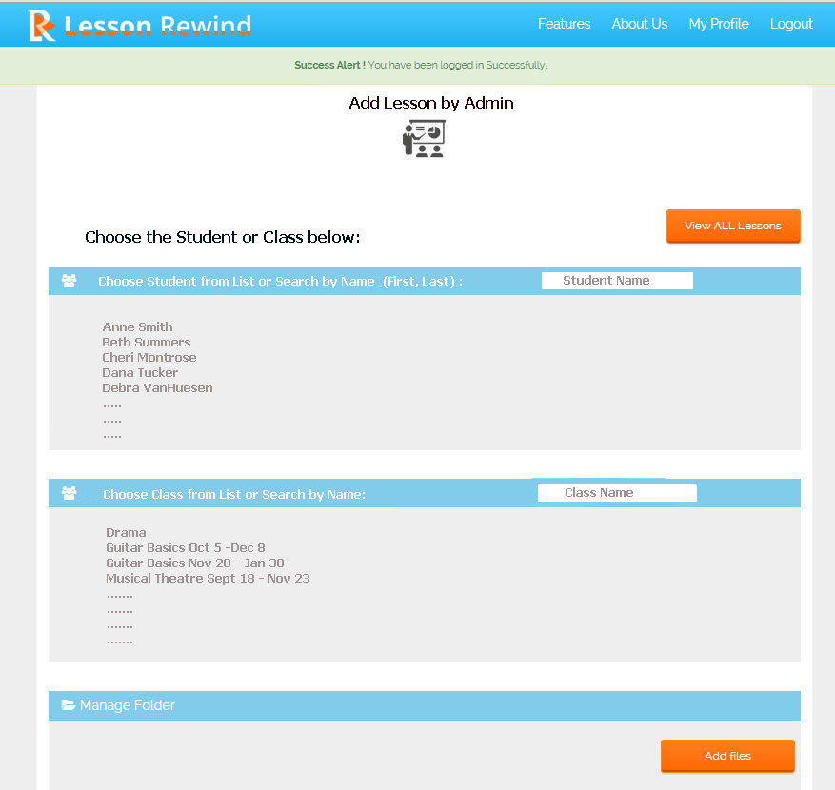

**Query:**

**As above comment you want an option to add lesson in admin dashboard. When any lesson is added then that lesson is linked with particular teacher and particular lessons are shown in particular teacher’s dashboard. So now when lesson is created by school user then how lesson will linked with teacher?**

1. In order to hopefully streamline the layout, I’m changing the sidebar categories and some associated pages. Also adding a category for “School Admins”

**Query: How “School Admins” will added and who can add “School Admins”. Please Explain.**

1. - I am getting erroneous “Email Address” information when I click to the “Add New School” page. Here is the view from the “Manage Schools” page which has the correct email addresses for these schools. (below)

**Query: We have tested above point we can’t get above error. Can you please make a video how you get this issue. So we can find out what is the error.**

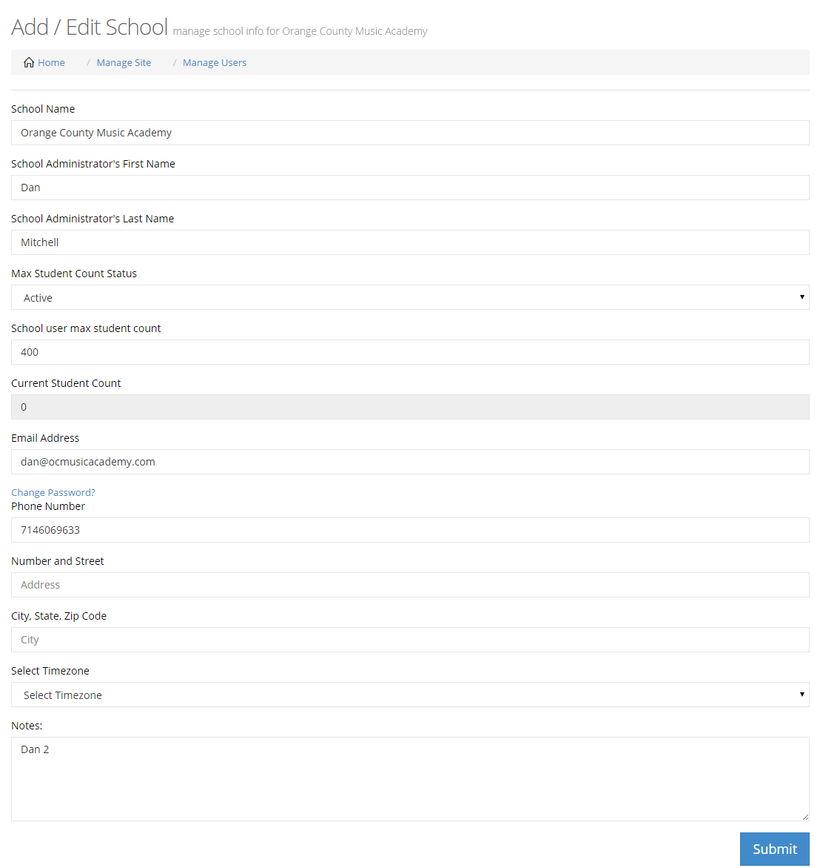

1. I’ve created some lessons for “student A” that have somehow attached videos from other lessons that I had done previously for “student B”. I’m not sure if that had anything to do with the lessons that I deleted when we added the “Lessons for Classes” function.

When I recorded a 4 minute video, it recorded fine. Then I sent the lesson. The lesson didn’t appear in the lesson list. The student did receive the notification email that the lesson had posted, but when he went to view it, the lesson was not there.++

**Query: Can you please give us login details of your account where you find above error.**